Newsletter Title | Newsletter Name
Hospital logo
hospital | Date
Meet [Insert Patient Name]
[Insert Local Patient Story: Patient story should start by focusing on the hobbies or dreams that patient had and how atrial fibrillation may have stopped them from doing those things. For ideas on great patient stories, visit GetSmartAboutAFib.com.]

Atrial fibrillation, also known as AFib or AF is defined as an irregular heartbeat that can lead to various heart-related complications such as blood clots, stroke, and heart failure. According to the Centers for Disease Control and Prevention, there are currently 5.5 million patients in the US diagnosed with | AFib and that number is expected to grow to more than 7 million by 2035. [Insert local AFib prevalence stat, if available].  While a fluttering or quivering heartbeat is the most common symptom of AFib, there are others that are less subtle.
“[Insert quote from patient highlighting their symptoms and diagnosis of AFib]”
Like, [insert patient name], many patients don’t understand the severity of AFib and the life-altering consequences it can have on them and their families. AFib increases a patient’s risk of stroke five-fold and becomes harder to treat as symptoms become more severe so it’s important to seek treatment early.  The most common type of treatment for AFib is drug therapy which includes taking medications to control the heart’s rhythm and rate and/or blood-thinning medication to prevent blood clots from forming and reduce stroke risk. Like nearly half of patients with |  |  |  |  | AFib, [insert patient’s name] still experienced symptoms while taking their medication and wanted something that would help improve his/her quality of life. That’s when [insert patient’s name] visited Dr. [insert EP’s name], electrophysiologist here at [insert clinic] for the first time.  An electrophysiologist is a cardiologist with extensive training in heart arrhythmias and the electrical activities of the heart. Dr. [Insert Name] specializes in the diagnosis, management and treatment of heart arrhythmias, including AFib.
“[Insert quote from doctor about his impression with patient and the reason catheter ablation was the best option]”

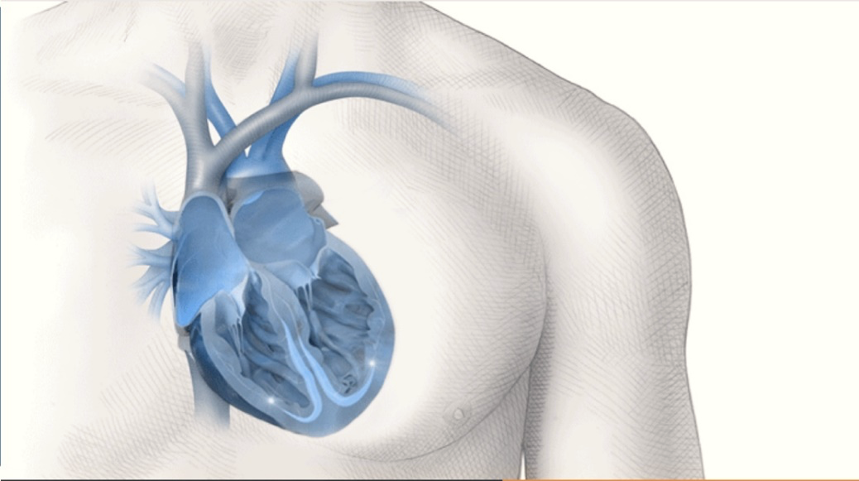 |  |  | Catheter ablation is a procedure which targets the areas of your heart generating faulty electrical pulses that cause a rapid heartbeat or AFib. By neutralizing and blocking these areas, the pulses are controlled and a normal heartbeat returns. For [insert patient’s name], and many others, this procedure has helped him/her return to normal and improve his/her quality of life [personalize this, if applicable].  Most patients who receive catheter ablation treatment experience a long-term reduction in both the number of episodes of arrhythmia and the severity of symptoms and many achieve a permanent return to normal heart rhythm.
“[Insert quote from patient highlighting how the catheter ablation procedure changed their life]”
For more information about AFib, visit GetSmartAboutAFib.com, or visit our website at [insert clinic website].
We will use your information as explained in our Privacy Policy [Insert link].
As with any medical treatment, individual results may vary. Only a cardiologist or electrophysiologist can determine whether ablation is an appropriate course of treatment. There are potential risks including bleeding, swelling or bruising at the catheter insertion site, and infection. More serious complications are rare, which can include damage to the heart or blood vessels; blood clots (which may lead to stroke); heart attack, or death. These risks need to be discussed with your doctor and recovery takes time. The success of this procedure depends on many factors, including your physical condition and your body’s ability to tolerate the procedure. Use care in the selection of your
doctors and hospital, based on their skill and experience.
THERMOCOOL® Navigation Catheters are indicated for the treatment of drug refractory recurrent symptomatic paroxysmal atrial fibrillation, when used with CARTO® 3 Systems (excluding NAVISTAR® RMT THERMOCOOL® Catheter).

Important information: Prior to use, refer to the instructions for use supplied with this device for indications, contraindications, side effects, warnings and precautions. Caution: US law restricts this device to sale by or on the order of a physician.

American Heart Association What is Atrial Fibrillation (AFib or AF)? Web Site. https://www.heart.org/en/health-topics/atrial-fibrillation/what-is-atrial-fibrillation-afib-or-af. Accessed July 2019.
Khavjou, Olga, D. Phelps, and A. Leib. “Projections of cardiovascular disease prevalence and costs: 2015–2035.” Dallas: American Heart Association (2016).
National Center for Chronic Disease Prevention and Health Promotion, Division for Heart Disease and Stroke Prevention. Atrial Fibrillation Fact Sheet. Accessed July 2019.
Win NT, Shyh PT. Atrial Fibrillation in Older Patients–Reducing Stroke Risk Is Not Only About Anticoagulation. Journal of Geriatric Cardiology (2016) 13: 880-882.
Calkins H, Reynolds MR, Spector P, et al. Treatment of Atrial Fibrillation With Antiarrhythmic Drugs or Radiofrequency Ablation. Circulation: Arrhythmia and Electrophysiology. 2009;2:349-361.
American Heart Association Ablation for Arrhythmias Web Site. https://www.heart.org/en/health-topics/arrhythmia/prevention--treatment-of-arrhythmia/ablation-for-arrhythmias. Accessed July 2019.
Wilber DJ, Pappone C, Neuzil P et al. Comparison of Antiarrhythmic Drug Therapy and Radiofrequency Catheter Ablation in Patients with Paroxysmal Atrial Fibrillation: A Randomized Controlled Trial. JAMA, 2010.

